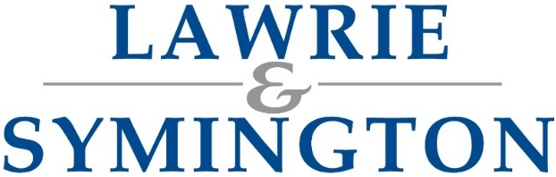 |  |  |  |  |  |  |  |  |  | Lanark Agricultural Centre  Hyndford Road, Lanark, ML11 9AX Email:implements@lawrieandsymington.com  Telephone: 01555662281/07747443260  Website: www.lawrieandsymington.com
ONLINE TIMED AUCTION IMPLEMENT SALE ENTRY FORM
Address:
Postcode:
VAT Reg: |  |  |  | VAT no:
Tel no: |  |  |  |  | Mob no:
Email:
Bank Details: |  | Sort code: |  |  |  |  | Account no:
 |  |  |  |  |  |  |  |  | DATE OF SALE:
Lot  (OFFICE USE ONLY) | Title (including make, model etc) |  |  |  |  | Age | Hours | Full Description (including working condition) |  |  | Reserve Price
Entry Form/Images to be sent to implements@lawrieandsymington.com (Images must show condition of each item including any flaws).
Entries will be advertised on our social media platforms. Videos can now be included with entry (please confirm permission to do so with entries otherwise video CANNOT be uploaded)
CONDITIONS OF SALE
- Payment by purchasers – Strictly Card or Cleared Funds prior to items being uplifted from our yard.
- All items sold must be delivered to Lanark sale yard by 12pm the following Thursday after the sale.
- No items can be delivered or uplifted from our yard on Monday’s.
- All items not delivered to our sale yard by the Thursday after the sale will be charged at £10 per item, per day.
- Items may be delivered to our yard prior to the sale, which will be at Vendors risk.
- Description, warranties & guarantees - All descriptions given are those of the Vendors & not of the Auctioneers. Any item described as in working or running order or condition shall have no defect which renders it incapable of the reasonable work for which it is intended & must be capable of performing such work. No item shall be returnable for any description, warranty or guarantee other than that affecting its working, running or mechanical condition. No description other than year of make, maker’s name, and type will be given unless warranted in working or running condition. The Auctioneers accept no responsibility for damage due to frost.
- If the condition of the item is not marked on the entry form, then Lawrie & Symington Ltd reserve the right to class as Spares/Repairs on Auctionmarts.com.
COMMISSION CHARGES
- Commission will be charged on all lots at 10% on FIRST £400 of any lot and 5% thereafter (e.g., Sold at £550 = £40+£7.50=£47.50), capped at £400 per lot. Minimum £5 per lot.
- All purchases will be subject to a 4% plus VAT buyer's premium on all lots capped at £400 per item sold by auction or by private treaty.

ENTRY FEES (NON-REFUNDABLE)
- Tractors, telehandlers, vehicles £10 plus VAT
- All other items: £2 plus VAT
RECEPTION AND DISPATCH OF GOODS
- Will be Tuesday till Friday – 8.00am till 4.00pm, otherwise be strict appointment with the auctioneers.
PAYMENT TO VENDORS
- Sale proceeds will be paid by BACS within 21 days..
- The Auctioneers act solely as agent between the Vendor and Purchaser and in the event of any dispute or refusal to pay of non-payment on the part of the Purchaser, they may at their discretion, annul and cancel the sale of such lot(s).
- All Sales will be conducted under the Lawrie & Symington Ltd and Livestock Auctioneers Association Conditions of Sale, which are available for inspection at our office
VENDORS DECLARATION
- I have read and understood the TERMS AND CONDITIONS and undertake to present the above (and those on continuation sheets) for sale and to abide by these Terms and Conditions of Sale.
- I certify that the items entered for sale are my/our sole property and are not subject to any hire purchase agreement or any other contract.
- I grant permission for any videos that I submit to be uploaded to YouTube for use for the online auction.

Owners Signature: Date:

Lot  (OFFICE USE ONLY) | Title (including make, model etc) | Age | Hours | Full Description (including working condition) | Reserve Price

