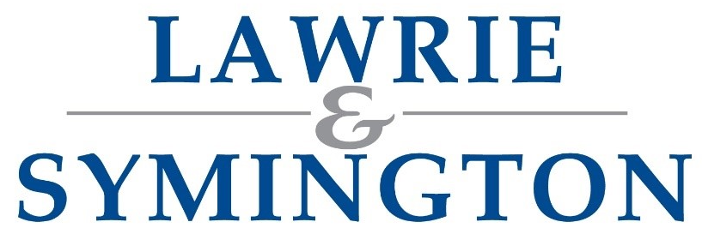

Bidding on our Online Auctions

How to register with Auctionmarts and Lawrie and Symington:

Visit Auctionmarts website – www.auctionmarts.com

If this is your first time on Auctionmarts press login/register at top of page and click Create an Account (if already registered with Auctionmarts go to step 5.)

Fill in details as requested and click Register

Go to your emails and find email from Auctionmarts to verify your email address and click link

Now register with Lawrie and Symington – click auctioneers at top of website and pick Lawrie and Symington from drop down menu and click Filter – Below our Logo you will see Register click that and add your details.

Lawrie and Symington will then approve your account and set your credit limit at £5000 if you need a larger credit limit, please arrange with our office staff on 01555 662281.

How to bid: https://www.auctionmarts.com/help/bidding

