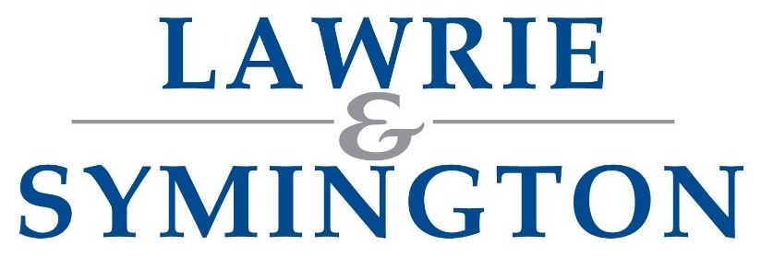
LANARK AGRICULTURAL CENTRE

CHRISTMAS SHOW AND SALE OF
PRIME STOCK, CAST COWS, CALVES, DAIRY CATTLE AND PRIME SHEEP
(Completed Schedules can be returned to: jenna@lawrieandsymington.com)

MONDAY 1ST DECEMBER 2025  Show and Sale of Prime Cattle and Cast Cows  Kindly sponsored by: tbc  Prime Cattle Judge: Mr Jim Findlay, Collins Butchers  Store Cows Judge: Mr Brian Gilvear, Graystale  Judging Times:  Prime Cattle 10.30am (forward by 10.00am)  and Store Cows 12.00 noon (forward by 11.30am) | MONDAY 1ST DECEMBER 2025  Show and Sale of Calves  Kindly Sponsored by: Roadhead Farm Feeds  Judge: Mr James Ogilive, Ballencrieff Mains  Judging at 9.45am (forward by 9.30am)
MONDAY 8TH DECEMBER 2025
Show and Sale of Prime Lambs

Kindly sponsored by: tbc
Judge: tbc

Judging at 9.45am

CONDITIONS OF SALE
All stock entered for the competition to be the property of the Exhibitor and must have been in his or her possession since 1st November. Animals can only compete in one class. The decision of the Judges to be final. In the event of any prize animals on exposure to Sale being withdrawn, or not sold bona fide by auction in the Ring, the prize money will be forfeited.

The following Stock will be sent for Sale on: Monday …………… December 2025

Class for which entered Numbers Class of Stock Particulars

EXHIBITOR NAME:
ADDRESS:
POSTCODE:
CONTACT NUMBER:
EMAIL ADDRESS:
SIGNED AND DATE:
Schedule Overleaf /

MONDAY 1ST DECEMBER 2025

CALVES at 9.45am
Judge: Mr James Ogilivie | Calves to be Under 70 Days  unless otherwise stated |  | Kindly sponsored by:  Roadhead Farm Feeds
- Native Bull Calf | - Native Heifer Calf |  | - Continental Bull Calf
- Continental Heifer Calf | - Dairy Bull Calf |  | - Beef Sired Stirk  (Bull or Heifer, Over 70 Days)
- Champion Calf |  | - Reserve Champion Calf

PRIME CATTLE at 10.30am
Judge: Mr Jim Findlay |  | Kindly sponsored by: tbc
- Limousin Bullock | - AOB Bullock | - Limousin Heifer
- AOB Heifer | - Native Bred Bullock or Heifer | - YFC Bullock or Heifer  (Exhibitor must be full member and aged between 14-28)
- Young Bull | - Champion  - (For the Lawrie & Symington Perpetual Trophy) | - Reserve Champion
- Highest Placed Limousin Bred (For the James Strachen Trophy) | - Best Native Bred | - Best Opposite Sex

STORE COWS at 12.00 noon

Judge: Mr Brian Gilvear | Kindly sponsored by: tbc
- Champion Beef Cow | - Champion Dairy Cow

MONDAY 8TH DECEMBER 2025

PRIME SHEEP at 9.45am

Judge: tbc | (2 entries per class / No weight categories) | Kindly sponsored by: tbc
- 5 Suffolk Cross Lambs | - 5 Texel Cross Lambs | - 5 Beltex Cross Lambs
- 5 AOB Cross Lambs | - 10 Blackface Lambs | - 10 Scotch Mule Lambs
- 10 Cheviot Lambs | - Champion Pen  (For the Joe Murray, Faugh Beeches Perpetual Memorial Trophy) | - Reserve Champion Pen

