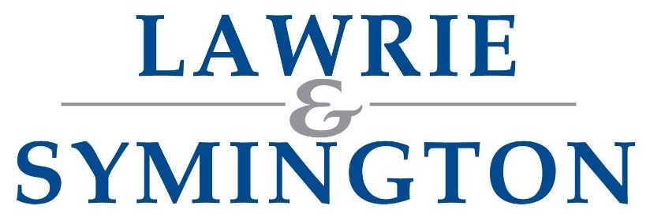

Our Ref: AH/JWB

6th November 2025

Dear Breeder,

Please find enclosed details and entry form ahead of this year’s Lanark Ladies.
Sale: | ‘Lanark Ladies’ - Show & Sale of In-Lamb Texel Females & Empty Ewe Hoggs followed by Sale of AOB In-Lamb Females & Empty Ewe Hoggs
Show & Sale Date: | Friday 9th January 2026 at 5.30pm (Texel Judging: 4pm)  Texel Judge: Mr Jamie Orr, Walston flock
Classes: | Aged Ewe, Gimmer/Shearling Ewe, Ewe Hogg, Embryo Recipient
Status of Sale: | MV-Accredited and Non-MV Accredited and Non-Eligible for Export  (Any pedigree sheep must be fully registered with relevant Breed Society prior to entry)
Closing Date(s): | Texels: Pre-Entries via Texel Website – closing Tuesday 9th December at strictly 12 midnight  All entries (including Texel Full Entries via iTexel) – Wednesday 17th December at strictly 10am
Entry Fees: | £12ph (£10+VAT) – (Payable to Lawrie & Symington Ltd and MUST be paid by submission of Entries, otherwise entries will be withdrawn from Catalogue).  Bacs Details: Sort Code 80-17-02 / Account Number 00110611 (Ref: Surname, Ladies)  Pedigree Texels, please note: Entry Fees charged based on Pre-Entries and will be collected by Texel Sheep Society via Direct Debit
Pedigree Certificates: | If applicable, please forward with entries
Substitutes: | To Lanark Office no later than Wednesday 7th January 2026  (Substitutes Catalogue will be available on website/day of sale)
Online Bidding: | Via MartEye (www.marteye.ie)

NO LATE ENTRIES WILL BE ACCEPTED. Entries can be returned to the Lanark office or can be emailed to jenna@lawrieandsymington.com or Whatsapp on 07799 845923. No entries will be accepted over the phone.

We thank you in anticipation of your entries, and if we can be of further assistance, then please do not hesitate to contact myself on 07917 624409; Charlie Reid 07427 970262: or Jenna Ballantyne on 07799 845923.

Yours faithfully
For LAWRIE & SYMINGTON LIMITED
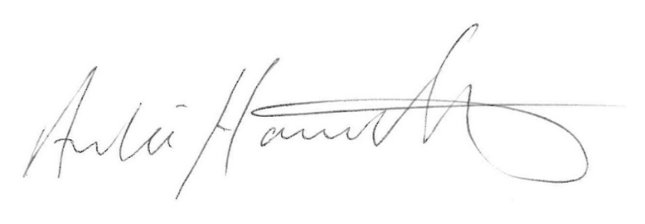
Archie Hamilton A.I.A. (Scot)
Head of Sheep

Enc.

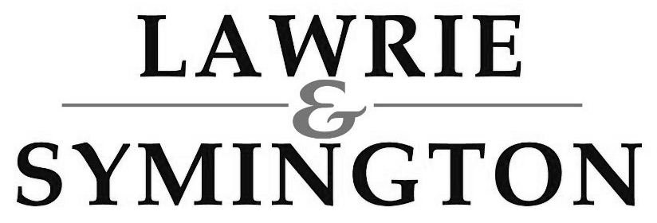
LANARK LADIES – ENTRY FORM

SALE OF MV-ACCREDITED IN-LAMB FEMALES AND EMTPY EWE HOGGS

SALE: Friday 9th January 2026 at 5.30pm (Texel Show: 4pm) (Open to both MV-Accredited and Non-MV Accredited Stock)
ENTRIES CLOSE: Wednesday 17th December 2025 at strictly 12noon
(Pedigree Texel Entries are to be submitted directly via iTexel)

Vendor Trading Name: |  | Flock Code AND Name:
Address (inc. Postcode)
Contact Number: |  | Email Address:
Farm Assured Number (if applicable)  (FA / SA / Non-FA) No: __________ | MV Status: MV or Non-MV | Or VAN Number (supplied by Vet)  (XXXXXXX-XX/XXX/XXXX-XXXX)

BREED | AGE CATEGORY  (Ewe, Gimmer, Ewe Hogg, Recip) | EAR TAG OF ANIMAL  (Including Ear Tag & Name) | SIRE’S DETAILS  (Including Ear Tag & Name) |  | DAM’S DETAILS  (Including Ear Tag & Name)
1.

SERVICE DETAILS  (Or Implant Date) |  |  |  | SCANNING RESULTS  (Or Embryo(s) Implanted)
NOTES

2.

SERVICE DETAILS  (Or Implant Date) |  |  |  | SCANNING RESULTS  (Or Embryo(s) Implanted)
NOTES

Continued Overleaf /
If you wish to include any Reference to Sires and/or Service Sire Notes or more entries, please continue them, on a separate sheet of paper, and enclose along with your entry form

LANARK LADIES – ENTRY FORM (Cont.)
BREED | AGE CATEGORY  (Ewe, Gimmer, Ewe Hogg, Recip) | EAR TAG OF ANIMAL  (Including Ear Tag & Name) | SIRE’S DETAILS  (Including Ear Tag & Name) |  | DAM’S DETAILS  (Including Ear Tag & Name)
3.

SERVICE DETAILS  (Or Implant Date) |  |  |  | SCANNING RESULTS  (Or Embryo(s) Implanted)
NOTES

4.

SERVICE DETAILS  (Or Implant Date) |  |  |  | SCANNING RESULTS  (Or Embryo(s) Implanted)
NOTES

5.

SERVICE DETAILS  (Or Implant Date) |  |  |  | SCANNING RESULTS  (Or Embryo(s) Implanted)
NOTES

6.

SERVICE DETAILS  (Or Implant Date) |  |  |  | SCANNING RESULTS  (Or Embryo(s) Implanted)
NOTES | If you wish to include any Reference to Sires and/or Service Sire Notes or more entries, please continue them, on a separate sheet of paper, and enclose along with your entry form

