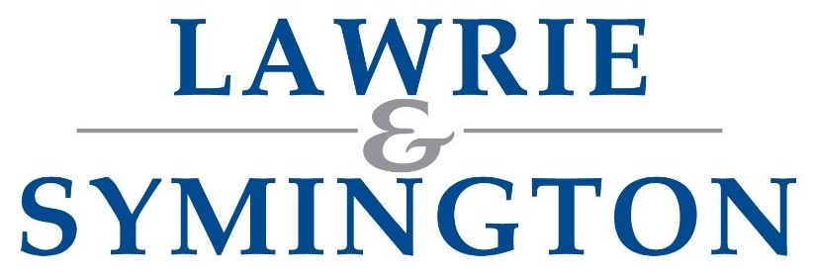 | 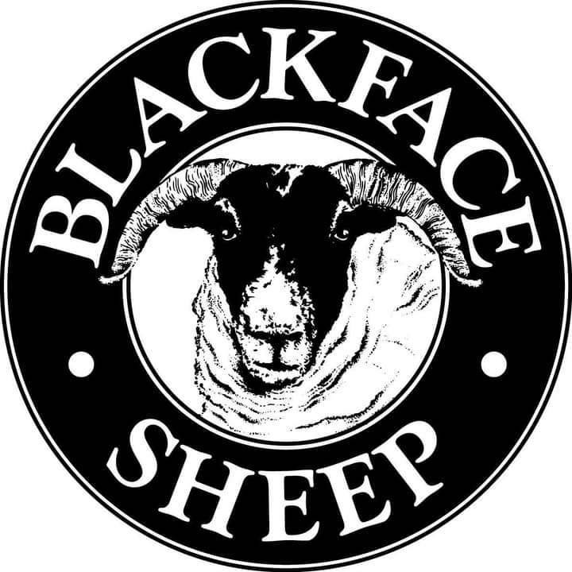

SHOW & SALE OF IN-LAMB FEMALES & EMPTY EWE HOGGS
(On behalf of the Blackface Sheep Breeders Association)

SALE INVITATION

SATURDAY 28TH FEBRUARY 2026
Show: 11.00am Sale: 12.00noon

Judge: Mr Robert Shaw, Acharonich

Online Bidding via: | 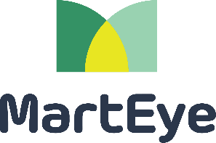

As part of our new drive to build on our Pedigree Sheep Sales,
Lawrie & Symington Limited extend an invite to you to perhaps consider supporting the above event with an entry or two

If you have anything to offer, please provide your entry to Breed Manager,
Aileen McFadzean – 07768 820405 or 01738 634018
aileen@scottish-blackface.co.uk

Entries Close (c/w Fees): Saturday 14th February (direct to Breed Manager)

Further Sale(s) Information available from:
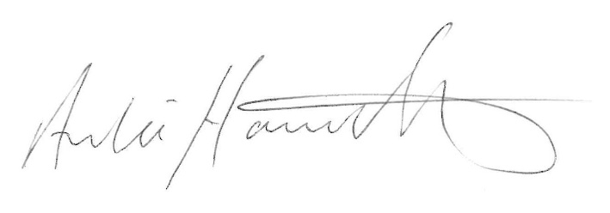 | 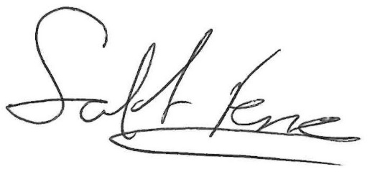
Archie Hamilton A.I.A. (Scot)  Head of Sheep – 07917 624409 | Scott Ferrie F.I.A. (Scot)  Business Operations Director – 07557 260653
Sale Dates for 2026 Overleaf /

DATES FOR 2026

Saturday 28th February | Show & Sale of In-Lamb Females and Empty Ewe Hoggs  (on behalf of the Blackface Sheep Breeders Association)
Wednesday 9th September | Blackface Ewe Lambs
Tuesday 22nd September | Principle Sale of Blackface Ewes & Blackface Gimmers  Second Sale of Lowland Breeding Sheep including Scotch Mule & Continental Ewes, Gimmers & Ewe Lambs  Second Sale of Blackface Ewe Lambs  “September Soiree” of All Classes of Rams
Friday 9th October | Second Sale of Blackface & Cheviot Ewes, Gimmers & Ewe Lambs  All Classes of Lowland Breeding Sheep  Sale of All Classes of Rams
Thursday 15th October –  Friday 16th October | Annual Two-Day Sale of Blackface Rams (Thursday) & Ram Lambs (Friday)  (Under the auspices of the Blackface Sheep Breeders Association)
Friday 23rd October | Late Sale of Breeding Sheep (NB: No Rams)
Thursday 29th October | “Final Fling” - Sale of all classes of Rams & Ram Lambs  including Second Sale of Blackface Rams & Ram Lambs  (Under the auspices of the Blackface Sheep Breeders Association)

All to commence at 10.30am unless otherwise advertised

UPDATE OF ACCOUNT – EMAIL ADDRESS

If you have received this letter/catalogue via Royal Mail, then Lawrie & Symington Ltd do not hold a valid email address for yourself, or it has failed to send.

Due to ever rising costs, the company are now emailing most of our customers with up-to-date information/catalogues when available.

If you have an email address, can we ask you to email jenna@lawrieandsymington.com to update your account, please include your Trading Name and Address when replying.

BLACKFACE SHEEP BREEDERS’ ASSOCIATION

SHOW & SALE OF IN LAMB FEMALES & EMPTY EWE HOGGS

SATURDAY 28TH FEBRUARY 2026 within Lanark Agricultural Centre
This will also be an online sale

Judge:- Robert Shaw, Acharonich ENTRY FORM
ENTRIES CLOSE 14th FEBRUARY 2026

NAME………………………………………………………… ADDRESS……………………………………………………………………………………………………………………………..

POSTCODE…………………………….. TEL NO…………………………………………………… EMAIL …………………………………………………………........................

SCRAPIE STATUS…………………………………………………. MV STATUS………………………………… EMBRYO’S COLLECTED YES/NO………………….. ENTRY FEE - £12.00 (inc VAT) PER SHEEP
TAG NO | AGE | SIRE | SIRE OF DAM | SERVED BY | OTHER INFO
Further Entries can be continued on a separate Entry Form
- THIS IS NOT AN EXPORT ELIGIBLE SALE – as exports are still banned due to the Bluetongue outbreak.
- Show 11.00am, Sale12.00pm.
- Pedigrees and tag numbers must be given of sheep to be sold individually and will be printed in the catalogue. Substitutes will be allowed but have to be notified by 12noon on 26th February.
- All sheep must be guaranteed in lamb at time of sale (unless hoggs) and if it has been flushed this must be declared.
- Sheep will be sold in guineas and the guineas will go the BSBA.

PLEASE RETURN THIS FORM WITH YOUR ENTRY MONEY TO: Aileen McFadzean, Woodhead of Mailer, Perth, PH2 0QA or
email entries to aileen@scottish-blackface.co.uk / Cheques to Blackface Sheep Breeders Association or BACS to 834700 ac 11533627

