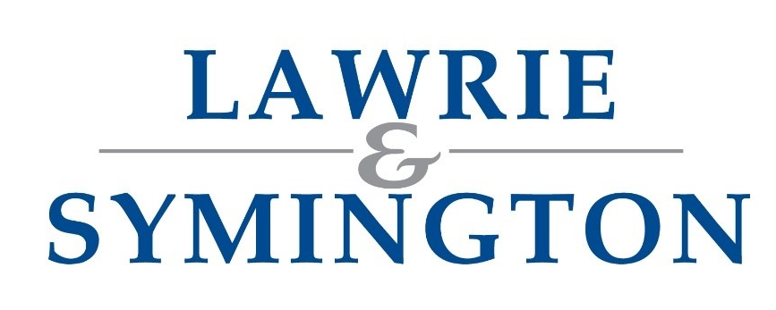
Our Ref: AH/JWB

20th May 2026

Dear Sirs

KELSO RAM SALES – FRIDAY 11TH SEPTEMBER 2026



Please find enclosed/attached this year’s Kelso Ram Sales Entry Form accompanied with the BUAS Bye Laws.

We are now beginning to collate our entries as normal and proceed as previous.

The BTV hard border is coming into place between 1st June and 10th September at present (subject to change), therefore any Rams coming from South of the Border will have to be Pre-Movement Tested.

As one of the major Auction companies participating at these sales, Lawrie & Symington Ltd would be delighted to invite you to sell your rams with us in any of our main sale rings as listed below:

Ring 3: MV Crossbred | Ring 6: MV Charollais | Ring 7: MV Registered Texel
Ring 9: MV Registered Texel | Ring 14: Non-MV Suffolk | Ring 15: Non-MV Bluefaced Leicester
Ring 16: Non-MV Crossbred |  | Ring 19: Non-MV & Un-Registered Texel
(Any Other Breeds not listed above will be gladly accepted and accommodated accordingly)

National and online advertising along with our existing list of purchasers, will allow the company to contact our extensive customer base on your behalf. Our experienced staff will, as always, ensure the best possible service both prior to and during the event.

We hope that you will continue to support us with your ram entries and we look forward to a positive sale.

Entries close Wednesday 22nd July at strictly 12noon. These can be emailed to jenna@lawrieandsymington.com or Whatsapp to Jenna on 07799 845923.

Entry fees will be deducted from sale proceeds and should not be sent with your entry. Also, the auctioneers’ headage charges will be borne by ourselves and not passed on to the customer.

Please find enclosed/attached this year’s Kelso Ram Sales Entry Form accompanied with the BUAS Bye Laws.

We look forward to receiving your entries, but should you have any queries, please do not hesitate to contact myself on 07917 624409; Scott Ferrie 07557 260653; Charlie Reid 07427 970262; or Jenna Ballantyne on 07799 845923.

Yours faithfully
For LAWRIE & SYMINGTON LIMITED
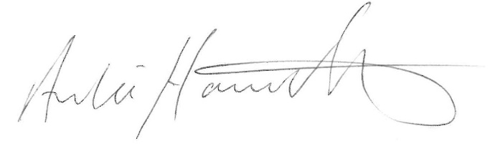
ARCHIE HAMILTON A.I.A. (Scot)
Head of Sheep Sales

Enc.


Kelso Ram Sales - Bye Laws 2026

- The Sales shall be held annually at Kelso on the second Friday of September (Friday 11th September 2026)
- Notice of all Lots of sheep intended to be brought forward for sale must be lodged with the Auction Company employed, at a date set by them, and in good time prior to the date fixed by the Committee for the close of entries, which is Monday 3rd August 2026
Note to Auction Companies; All Entries must be made on the appropriate forms and submitted to the Border Union Agricultural Society, Kelso, not later than 5.00 p.m. on Monday 3rd August. Entries will not be accepted by telephone at any time. Amendments to entries must all be submitted in writing to the Society office (emails are accepted)
- Each Auction Company will be held responsible for payment to the Border Union Agricultural Society of all entry money in respect of all sheep entered for the Sales by that Company at the rates laid down by the Committee
- The Committee shall determine the number of Sale Rings it may be necessary to have and the order in which the several lots of sheep shall be brought forward
- Each Lot of sheep shall be sold in the Ring fixed by the Committee and in the order of the Ballot and in that Ring only and the Auctioneer exposing such Lot and the owner of such Lot shall be bound to see that this rule is strictly carried out
- Any Consignor, within one Ring, failing to present at least 75% of the number of sheep balloted will be liable to a penalty as set out in Rule 7, unless they can satisfy the Committee as to the reason for the non- presentation of rams. Where applicable a Veterinary Surgeon’s Certificate must be produced prior to the Sales stating number of sheep examined and cause of their non- presentation
- In the event of any infringement of Rules 5 or 6 the party so infringing them shall be liable to a penalty of not less than £60, or £6 per sheep, whichever is the greater, and for all loss and damage which may be sustained, and furthermore, the Committee are empowered to refuse future entries from any Consignor infringing the said rules
- Entry Money – The Fee payable will be £22 + VAT for each ram entered. Each Lot of 5 rams and under which will be charged a Minimum Entry Fee of £110 + VAT. VAT will be added to all charges at the current rate (20%). All Entry Fees AND Auctioneers Charges must be paid by the Auctioneers. If, for whatever reason, sheep are withdrawn after the entries are lodged with the Border Union Agricultural Society then payment is still required
- The whole sheep shall be penned and the Sales shall commence at all the Rings at such time as shall be arranged by the Committee, traditionally this is 10.00 am
- Each Lot must be in the Collecting Pen in the division to which it belongs as the last sheep in the preceding Lot shall have been disposed of
- Any Lots that may not be ready in the Collecting Pens when their turn for selling arrives will not be allowed to come forward until all the others in that division have been disposed of
- No Consignor can have two ballots in any one Breed of sheep unless they have 40 or more sheep of that Breed entered for sale. The number of Rams must be divided equally if exposed in one Ring
- No Consignor to be allowed more than two ballots of any one Breed of sheep
- In the case of two ballots the number presented for sale must be in proportion to the number balloted
- Sheep withdrawn must not be re-exposed for sale. Any Consignor contravening this rule will be liable to a fine of £100 per sheep
- Sheep not balloted will not be eligible for entry to the Sales. Any Consignor contravening this rule will be liable to a fine of £100 per sheep
- Loss or Damage: The Directors of the Border Union Agricultural Society accept no responsibility or liability whatever the loss, injury or damage to any person, animal or property on the Showground or its approaches
- Shepherds or owners must remain in charge of their respective Lots until 5.30 pm on the day of the Sales and will be responsible to see that purchasers get proper delivery up to that hour (when the Sales are officially closed). Any rams delivered after 5.30 p.m. are at the entire risk of the purchaser
- In the event of any Consignor guaranteeing rams as stock-getters, intimation of any claims in respect of rams not fulfilling the warranty must be intimated TO THE AUCTIONEER before 11th December following the Sales, accompanied by a Veterinary Surgeon’s Certificate. The amount of any claim will be restricted to the purchase price of the ram and will not include any loss of profit or consequent loss or any other claim
- NO RIGS shall be exposed for sale at the Border Union Kelso Ram Sales
- Maedi-Visna Accredited sections will be provided where applicable. All M.V. Accredited Rams will be eligible to be sold in the Accredited section. This MUST be intimated to the Auctioneers at time of entry otherwise they will be sold in the Non-Accredited Maedi Visna section
- All Rams presented for sale must:
  - Be in a fit and healthy condition, in accordance with the Welfare of Animals at Markets Order 1990 (WAMO 1990 As amended)
  - Be the bona fide property of and in the possession of the Consigner from 1st August 2025
- Sheep Scab Preventative Measures:
All sheep must be treated with a licensed product for the control of sheep scab, in accordance with the manufacturer’s instructions, within 14 days prior to their arrival at the Ram Sales
- The Ram Sales Committee reserve the right to appoint Veterinary Surgeons to carry out random inspections on any individual ram or Lot on the Showground. If any evidence of infectious or contagious disease, for example CLA, Orf, etc., is suspected, the individual Ram or all Rams from that Consignor may be expelled from the Showground. The decision of the Veterinary Surgeons will be final
- All Auctioneers participating at the Ram Sales must be valid Members of either the Institute of Auctioneers and Appraisers in Scotland or the Livestock Auctioneers Association and in addition are employed by or are a corporate Member of either of these organisations
- There will be strictly NO SMOKING in any Marquee at any time
- All Rams should be clearly numbered on their back. If any Rams are not clearly numbered on their back, they will not be eligible to be sold in the Sales. The only exception to this Rule is Registered Bluefaced Leicester, which shall be numbered using a plastic yellow label (provided by BUAS) secured round the Ram’s neck
- It is a condition of entry that all Consignors accept, and comply with, the Bye Laws of the Border Union Kelso Ram Sales

KELSO RAM SALE ENTRY FORM Entries Close: Wednesday 22nd July 2026 at strictly 12noon

Breed | Flock Breed  No. / Code  (e.g., BYM or 1234) | Produce of  Reg. Flock | M.V.  Accredited | No. of Aged Rams (e.g., 2-Shear etc) | No. of  Shearling Rams | No of  Ram Lambs | Flock Name for Pen  (e.g., Roadend)
 |  | YES / NO | YES / NO
 |  | YES / NO | YES / NO
 |  | YES / NO | YES / NO
 |  | YES / NO | YES / NO
 |  | YES / NO | YES / NO
 |  | YES / NO | YES / NO

Entries to: LAWRIE & SYMINGTON LIMITED, LANARK AGRICULTURAL CENTRE, HYNDFORD ROAD, LANARK, ML11 9AX or email to: jenna@lawrieandsymington.com or Whatsapp to: 07799 845923

Full Trading Name:
Address & Postcode:
Contact Number: |  | CPH & UK Herd/Flock Number:
Email: (Compulsory) |  | Veterinary Attestation Number (V.A.N.)  (If applicable/valid for ONE year)
Bank Sort Code: (if applicable) |  | Bank Account Number: (if applicable)

