Our Ref: AH/JWB

1st September 2026

Dear Sir/Madam

BLACKFACE RAM SALES 2026

It has quickly come back around to that time of year again when we are asking for your entries for the Annual Blackface Shearling and Ram Lamb Sales (Under the auspices of the Blackface Sheep Breeders Association).

This year the sale dates are as follows:

Thursday 15th – Friday 16th October (Shearlings - Thursday / Ram Lambs – Friday)
Entries and Pens required to be intimated by Wednesday 7th October at strictly 12noon.
A public ballot will be drawn upon on Wednesday 7th October (time tbc) and will be livestreamed via Ring 1 Webcam

Thursday 29th October – “Final Fling” – Second Sale of Blackface Rams and Ram Lambs
Entries and Pens required to be intimated by Wednesday 21st October.

As previously and for us to be able to advertise more accurate numbers, we respectively ask vendors to enter the correct number of Shearlings and/or Ram Lambs and request number of pens required. We would rather you entered 5 and asked for 2 pens than enter 10 to get 2 pens and bring only 5.

Please feel free to contact myself on 07917 624409, Scott Ferrie 07557 260653, Charlie Reid 07427 970262, Jenna Ballantyne 07799 845923 or the market office on 01555 662281 with any queries regarding these sales.

Thank you for your co-operation and always assuring you of our best attention.

If you have already entered your tups, thank you.

Yours faithfully
For LAWRIE & SYMINGTON LIMITED
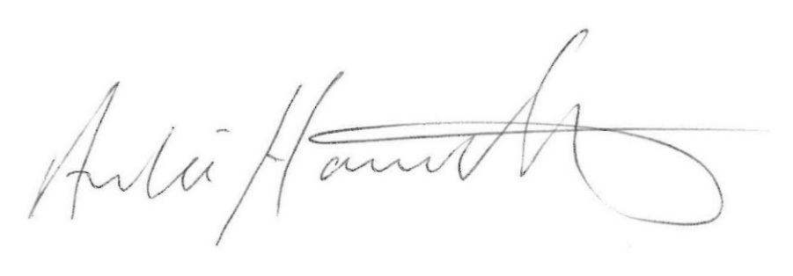
Archie Hamilton A.I.A. (Scot)
Head of Sheep Sales

